William Brent Lander

williambrentlander@gmail.com

Abstract

A data science review the demographics of neighborhoods in Toronto, Canada, combined with the current restaurant offerings in that neighborhood, give key insights into what type of restaurant has the best chance of having a good customer base. The results of this report are intended go into a business decision process, as part of an overall selection process.

Peer-graded Assignment: Capstone Project - The Impacts of Neighborhoods on Restaurant Success or Failure

Finding the Best Restaurant Opportunity for Each Neighborhood

Table of Contents

Introduction 1

Data Sources 2

Methodology 3

Analysis 4

Results 12

Discussion 13

Conclusion 13

Caveat Emptor 14

Table of Figures

Figure 1- Overview of Neighborhoods in Toronto Canada 1

Figure 2- Distribution of Top 20 Restaurant Venues in Toronto Canada 5

Figure 4- Count of Restaurants by Neighborhood, with 10 or more Restaurants 6

Figure 5- Restaurant Failures by Neighborhood 2017-2018 11

Figure 6- Restaurant Venue Failures in Toronto 2017-2018 12

Table of Tables

Table 1 - Reference Matrix Showing Where Questions are Addressed in Analysis and Results 2

Table 2 - Neighborhoods Defined by Statistics Canada but no Geospatial Information Available 4

Table 3- Number of Restaurants in Each Venue in Toronto 7

Table 4- Neighborhoods, Highest Count Venue, and Estimated Customer Base 7

Table 5- Count of Restaurant Failures by Neighborhood 2017-2018 9

Table 6- Most Common Venue Closings for Neighborhoods with Double Digit Restaurant Closings 10

Table 7- Some Neighborhood with Potential for Restaurants and Large Customer Base 13

# Introduction

The goal of this effort is to apply the tools and methodologies of data science in reducing the risk of starting a new restaurant in the Toronto area.

According to BPlans[1], a web site popular for promoting entrepreneurial business planning, the largest reason for restaurants failing is lack of planning. The research here can be applied early in the planning phase, providing location/competition market research. This early application allows for choices being made which reflect the impact of the choice of location (e.g., neighborhood), and choice of venue type, while avoiding areas where others have recently failed in their efforts.

This effort uses data science techniques, and available data, in an attempt to reduce risk in a potential new restaurant venture in the Toronto area. Restaurants tend to be neighborhood based – if they succeed, they will succeed in the surrounding neighborhood, and then expand their base. By using resources available on the Internet, a recommendation of the location and type of restaurant that is most likely to succeed is made. This recommendation would be used by the business developers, in combination with other business logic, for establishing a successful new venue.

In the course of this project, 208 neighborhoods were examined (with 200 having existing restaurants), with 103 different venues of restaurants, and a total of 25798 individual restaurants. The area included the city of Toronto and neighboring neighborhoods identifying with Toronto. This larger area was selected because the focus of the study is based on neighborhoods, and not political boundaries.

In a second phase of the study, an additional 208 restaurants were considered, separately, which had failed (35 different categories of restaurants over 69 neighborhoods) in an effort to understand adverse impacts.

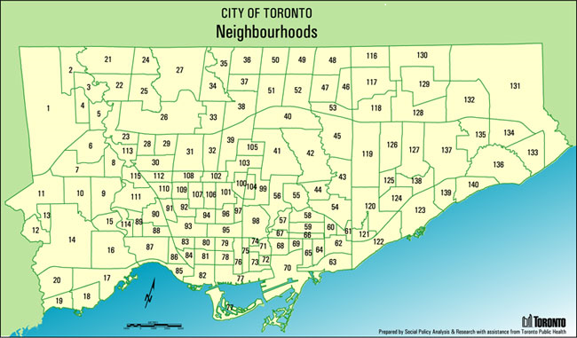

Figure - Overview of Neighborhoods in Toronto Canada

This work addresses the following analysis questions:

1. What are the most successful types of restaurants (e.g., coffee shops, national cuisine, snacks) in greater Toronto?
2. In what neighborhoods are successful restaurants currently located?
3. What types of successful restaurants are located in each neighborhood?
4. What types of restaurants failed in the recent past?
5. Where did those restaurants fail?

The following table provides guidance to where in the content the various questions are addressed.

Table - Reference Matrix Showing Where Questions are Addressed in Analysis and Results

|  |  |  |
| --- | --- | --- |
| **Question** | **Analysis** | **Results** |
| Q1 | A.3 | R.3 |
| Q2 | A.4, A.2 | R.4 |
| Q3 | A.5 | R.5 |
| Q4 | A.10 | R.7 |
| Q5 | A.8 A.9 | R.7, R8 |

# Data Sources

Demographic data came from Statistics Canada, the national statistical office, as published in 2016. Direct access to this information is no longer available outside Canada, but is reported in Wikipedia. This information included the list of neighborhoods, size (square kilometers), population, and average income.

Geolocation information for the various neighbors came from the Nominatim geolocator service (<https://nominatim.openstreetmap.org/>), and was used to generate the location (latitude/longitude) for the center of each neighborhoods.

Information about existing restaurants came from the Foursquare venue API,

<https://api.foursquare.com/v2/venues>

This information included the location, and categoryID (or venue category) for each specific restaurant. Foursquare describes itself as “a technology platform that powers leading business solutions and consumer products through a deep understanding of location.”

Additional information on the venues’ categoryID came from the Foursquare API documentation found at <https://developer.foursquare.com/docs/resources/categories> . This information linked the numeric categoryID to a verbal description (e.g., “Afghan Restaurant”, “Indonesian Restaurant”, “Korean Restaurant”). The Foursquare documentation also included a taxonomy of restaurants, allowing for a categorial roll up of some of the more specific categories. For example, “Korean Restaurant” can be either a “Korean Restaurant”, “Bossam/Jokbal Restaurant”, “Bunsik Restaurant”, “Gukbap Restaurant”, “Janguh Restaurant”, or a “Samgyetang Restaurant”.

Information on restaurant closures in 2017 and 2018 came from

“The RIP LIST: 150 Toronto restaurants that closed in 2017 “ <https://dailyhive.com/toronto/rip-list-toronto-restaurants-closed-2017>

“The RIP LIST: 147 Toronto restaurants that closed in 2018” [https://dailyhive.com/toronto/rip-toronto-restaurants-closed-2018](%20https:/dailyhive.com/toronto/rip-toronto-restaurants-closed-2018)

# Methodology

section which represents the main component of the report where you discuss and describe any exploratory data analysis that you did, any inferential statistical testing that you performed, and what machine learnings were used and why.

The following approach was taken:

1. Gather the list of neighborhoods. This includes the Statistics Canada information, and additional lists of smaller more ethnic-centered neighborhoods. This gave a list of 205 neighborhoods for potential examination.
2. Geo-locate (latitude, longitude) each of the neighborhoods. If no geolocation information is available, then remove those neighborhoods from further consideration. This resulted in the list of neighborhoods reduced to 191 neighborhoods.
3. Transcribe the restaurant taxonomy from the Foursquare documentation into a machine usable dictionary. This preparatory step allows later consolidation of restaurant categories where there is not a meaningful number of those restaurants.  
   Early analysis showed, for example, that the individual numbers for the sub-categories of Korean Restaurants only obscured the success of Korean Restaurants by diluting the numbers while not providing any additional insights.
4. For each neighborhood, query Foursquare about the available restaurants. Consolidate the restaurant venue breakdown by categories into the neighborhood data frame. Because Foursquare will only return information about 50 or less restaurants in a given query, the neighborhoods were divided into a series of circular sub-regions each of which was queried in turn. The Foursquare results were then compiled into a list, so that duplicate responses (e.g., the same restaurant being reported twice) were eliminated. In order to keep the number of responses from each sub-region less than 50, the size of each sub-region was reduced to a circle with a radius of 100 meters. The centers of the sub-regions were selected so that there were no gaps in coverage.
5. Examine the marginals over the data frame from step 4. Summing across rows tells the number of each category of restaurant in the greater Toronto area (this is an indicator of the popularity of various categories, the most popular is “Coffee Shop”, followed closely by “Pizza Place”). Summing down each column gives the count of restaurants per neighborhood (This gives an indication of how favorable a neighborhood is to restaurants, the most popular neighborhoods being “Willowdale” and “Little Italy”
6. Normalize the number of each category of restaurant with the population of each neighborhood. One of the important indicators of restaurant success is the size of the potential customer base. For example, if there is only one Italian Restaurant in a neighborhood of 1,000 people, the number of potential customers is larger than in one where there are 20 existing Italian Restaurants.
7. Cross check the results so far by looking at a map showing for each neighborhood what category of restaurant is most popular.

Begin looking at counter indicating evidence – restaurants closing in the past two years by neighborhood.

1. Collect the list of failed restaurants for 2017 and 2018, including name, venue, year of closure, and neighborhood where the restaurant was closed.
2. Examine the number of restaurant closings by neighborhood, for estimating how impenetrable a neighborhood is to a new restaurant.
3. Examine the number of closings by restaurant venue, determining which categories of restaurants are most likely for failing.

# Analysis

1. 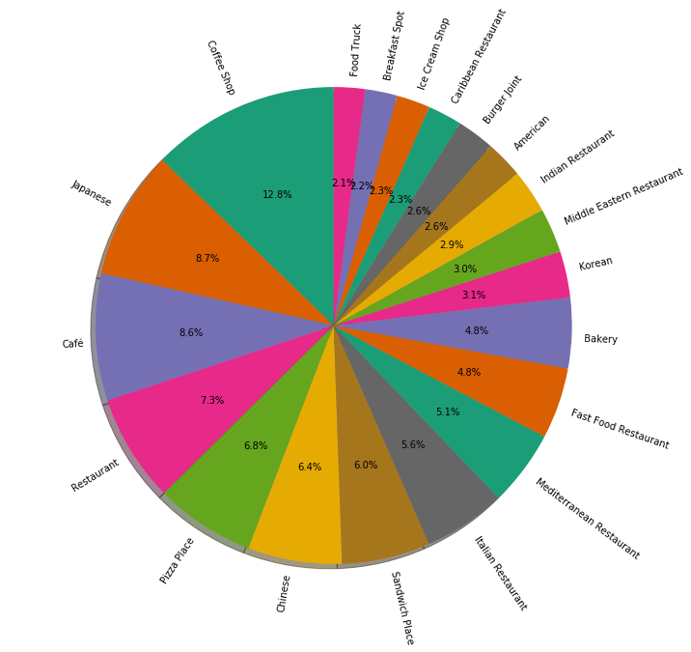The 20 most popular restaurant venues in Toronto are shown in Figure 2.The most popular venue is Coffee Shop. While Coffee Shops were most popular in the business neighborhoods, they were pervasive, and found in most neighborhoods. There were 103 different types of venue found, many with only one restaurant featuring that venue.

Figure - Distribution of Top 20 Restaurant Venues in Toronto Canada

1. During the geolocation phase, the location and size of the following neighborhoods in Toronto could not be determined, so were removed from further consideration:

Table 2 - Neighborhoods Defined by Statistics Canada but no Geospatial Information Available

|  |
| --- |
| Clairville |
| Cricket Club |
| Humber Bay Shores |
| Humbermede |
| Playter Estates |
| Princess Gardens |
| Regal Heights |

1. The histogram in Figure 3 shows the number of restaurants (across all venues) by neighborhood. Due to the number of neighborhoods, only those neighborhoods with 10 or more restaurants are shown. From this chart, it appears that the neighborhoods which are most

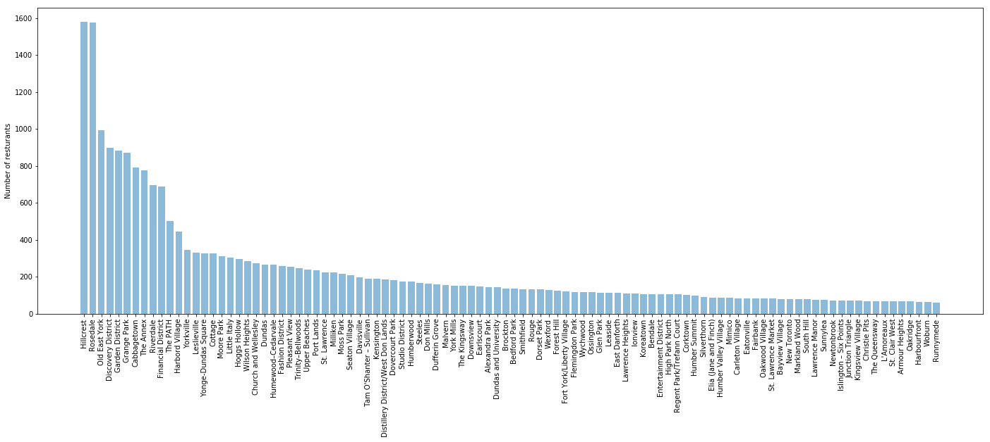

Figure - Count of Restaurants by Neighborhood, with 10 or more Restaurants

1. Table 3 shows the number of restaurants for the most popular venues. From this, it is very clear that Toronto’s citizens really like quick service restaurants. This venue breakdown was composed by FourSquare.

Table - Number of Restaurants in Each Venue in Toronto

| **Venue** | **Number of Restaurants** |
| --- | --- |
| Coffee Shop | 2446 |
| Japanese | 1661 |
| Café | 1646 |
| Restaurant | 1397 |
| Pizza Place | 1296 |
| Chinese | 1219 |
| Sandwich Place | 1146 |
| Italian Restaurant | 1071 |
| Mediterranean  Restaurant | 982 |
| Fast Food  Restaurant | 922 |
| Bakery | 914 |
| Korean | 599 |
| Middle Eastern  Restaurant | 579 |
| Indian Restaurant | 563 |
| American | 491 |
| Burger Joint | 489 |
| Caribbean  Restaurant | 441 |
| Ice Cream Shop | 435 |
| Breakfast Spot | 417 |
| Food Truck | 404 |
| Deli / Bodega | 372 |
| Greek Restaurant | 371 |
| Dessert Shop | 367 |
| Bubble Tea Shop | 310 |
| BBQ Joint | 299 |
| Hot Dog Joint | 298 |
| Juice Bar | 289 |
| Fried Chicken | 227 |
| Food Court | 215 |
| Tea Room | 214 |

1. The following table scales the population of a neighborhood with the number of restaurants of a given venue. Only neighborhoods with three or more of a given restaurant venue are shown. This gives an estimate of the size of the customer base.

Table - Neighborhoods, Highest Count Venue, and Estimated Customer Base

| Neighborhood | Venue | Customer Base | Current # Restaurants |
| --- | --- | --- | --- |
| Old East York | Tea Room | 8,703.30 | 6 |
| Woburn | Caribbean Restaurant | 8,084.50 | 6 |
| L'Amoreaux | Pizza Place | 7,643.70 | 6 |
| Malvern | Bakery | 7,387.30 | 6 |
| Willowdale | Coffee Shop | 7,190.70 | 6 |
| Elia (Jane and Finch) | Chinese | 6,857.60 | 7 |
| Downsview | Bakery | 6,102.20 | 6 |
| Newtonbrook | Chinese | 6,007.70 | 6 |
| Smithfield | Coffee Shop | 5,832.70 | Curr6 |
| Fairbank | Café | 5,686.80 | 6 |
| Riverdale | Bagel Shop | 5,167.80 | 6 |
| Bendale | Restaurant | 4,824.20 | 6 |
| Humewood–Cedarvale | Fast Food Restaurant | 4,585.80 | 6 |
| Tam O'Shanter - Sullivan | Caribbean Restaurant | 4,539.20 | 6 |
| Milliken | Pizza Place | 4,378.70 | 6 |
| West Hill | Fast Food Restaurant | 4,272.00 | 6 |
| Steeles | Pizza Place | 4,116.00 | 6 |
| Forest Hill | Portuguese Restaurant | 4,009.30 | 6 |
| Davisville | Sandwich Place | 3,954.50 | 6 |
| Leslieville | Mediterranean Restaurant | 3,927.80 | 6 |
| High Point North | Restaurant | 3,791.00 | 6 |
| York University Heights | Pizza Place | 3,734.30 | 7 |
| Scarborough Junction | Fast Food Restaurant | 3,682.90 | 7 |
| Don Mills | Burger Joint | 3,562.00 | 6 |
| Flemingdon Park | Restaurant | 3,547.80 | 6 |
| Upper Beacges | Snack Place | 3,305.00 | 6 |
| Eglinton East | Pizza Place | 3,198.10 | 7 |
| Eatonville | Chinese | 3,188.50 | 6 |
| Glen Park | Coffee Shop | 3,071.00 | 6 |
| East Danforth | Indian Restaurant | 3,062.90 | 7 |
| Hillcrest | Portuguese Restaurant | 3,054.50 | 6 |
| Wexford | Ice Cream Shop | 2,974.00 | 6 |
| Silverthorn | Indian Restaurant | 2,959.50 | 6 |
| O'Connor–Parkview | Japanese | 2,956.70 | 6 |
| Sunnylea | Coffee Shop | 2,933.70 | 6 |
| Amesbury | Restaurant | 2,886.30 | 6 |
| Earlscourt | Japanese | 2,873.30 | 6 |
| Victoria Village | Japanese | 2,841.20 | 6 |
| Rouge | Bakery | 2,840.50 | 8 |
| Pleasant View | Indian Restaurant | 2,769.20 | 6 |
| Islington Six Points | Coffee Shop | 2,751.30 | 6 |
| The Annex | Deli / Bodega | 2,600.30 | 6 |
| Thorncliffe Park | Pizza Place | 2,564.10 | 7 |
| Bathurst Manor | Middle Eastern Restaurant | 2,490.80 | 6 |
| Mimico | Breakfast Spot | 2,366.30 | 6 |
| Dorset Park | African | 2,364.80 | 6 |
| Kingsview Village | Japanese | 2,322.00 | 7 |
| Lawrence Manor | Restaurant | 2,291.70 | 6 |
| Bedford Park | Fast Food Restaurant | 2,291.50 | 6 |
| Ionview | Japanese | 2,170.80 | 6 |
| Guildwood | Chinese | 2,136.70 | 6 |
| Cliffcrest | Sandwich Place | 2,075.90 | 7 |
| Humber Valley Village | Korean | 2,064.70 | 7 |
| Harbourfront / City Place | Coffee Shop | 2,052.60 | 7 |
| Bayview Village | Coffee Shop | 2,046.70 | 6 |
| Leaside | Pizza Place | 1,982.30 | 7 |
| Wilson Heights | Juice Bar | 1,961.70 | 7 |
| Alderwood | Japanese | 1,942.70 | 6 |
| Church and Wellesley | Deli / Bodega | 1,913.90 | 7 |
| Oakridge | Fast Food Restaurant | 1,909.70 | 7 |
| Swansea | Coffee Shop | 1,855.50 | 6 |
| Cabbagetown | Bakery | 1,853.30 | 6 |
| Clairlea | Café | 1,850.70 | 6 |
| Humber Summit | Coffee Shop | 1,823.70 | 7 |
| Ledbury Park | Café | 1,765.70 | 7 |
| New Toronto | Bakery | 1,742.50 | 6 |
| Wallace Emerson | Coffee Shop | 1,723.00 | 6 |
| Dufferin Grove | Pizza Place | 1,645.80 | 6 |
| Highland Creek | Coffee Shop | 1,606.60 | 8 |
| Don Valley Village | Chinese | 1,565.30 | 19 |
| Brockton | Seafood Restaurant | 1,506.50 | 6 |
| Grange Park | Fried Chicken | 1,501.20 | 6 |
| Regent Park/Trefann Court | Restaurant | 1,483.90 | 7 |
| The Kingsway | Mediterranean Restaurant | 1,463.30 | 6 |
| Markland Wood | Coffee Shop | 1,462.90 | 7 |
| Trinity–Bellwoods | Pizza Place | 1,447.80 | 6 |
| Dovercourt Park | Restaurant | 1,416.20 | 6 |
| Garden | District Diner | 1,373.30 | 6 |
| Cliffside | Pizza Place | 1,340.90 | 7 |
| Little Italy | Mediterranean Restaurant | 1,319.50 | 6 |
| Rosedale | Greek Restaurant | 1,278.70 | 6 |
| Humberwood | Bakery | 1,219.80 | 6 |
| Distillery District/West Don Lands | Japanese | 1,063.00 | 6 |
| Yorkville | Food Restaurant | 1,007.50 | 6 |
| Harbord Village | Dessert Shop | 984.3 | 6 |
| Carleton Village | BBQ Joint | 934.9 | 7 |
| Niagara | Coffee Shop | 932 | 7 |
| Seaton Village | Chinese | 876.5 | 6 |
| Christie Pits | Ice Cream Shop | 854 | 6 |
| Summerhill | Italian Restaurant | 850 | 6 |
| Graydon Hall | York/Liberty | 785.7 | 6 |
| South Hill | Indian Restaurant | 777.2 | 8 |
| Corktown | Pizza Place | 747.3 | 6 |
| Moore Park | Chinee | 745.7 | 6 |
| Pelmo Park | Coffee Shop | 733.7 | 6 |
| West Deane Park | Pizza Place | 732.5 | 6 |
| Runnymede | Coffee Shop | 730.3 | 6 |
| Wychwood | Bakery | 697 | 6 |
| Junction Triangle | Breakfast Spot | 666.6 | 10 |
| Lawrence Park | Pizza Place | 665.3 | 10 |
| Fashion District | American | 663.1 | 7 |
| Fort York/Liberty Village | Japanese | 636.8 | 6 |
| Lawrence Heights | Bakery | 628.2 | 6 |
| Armor Heights | Coffee Shop | 626.3 | 7 |
| Alexandra Park | Mediterranean Restaurant | 622.1 | 7 |
| Old Mill/Baby Point | Bakery | 572.9 | 7 |
| Hoggs Hollow | Pizza Place | 520.5 | 6 |
| Port Lands | Fried Chicken | 95.2 | 6 |
| Financial District | Gastropub | 91.3 | 6 |

1. Geographically, the distribution of most popular types of restaurant venues looks as follows:

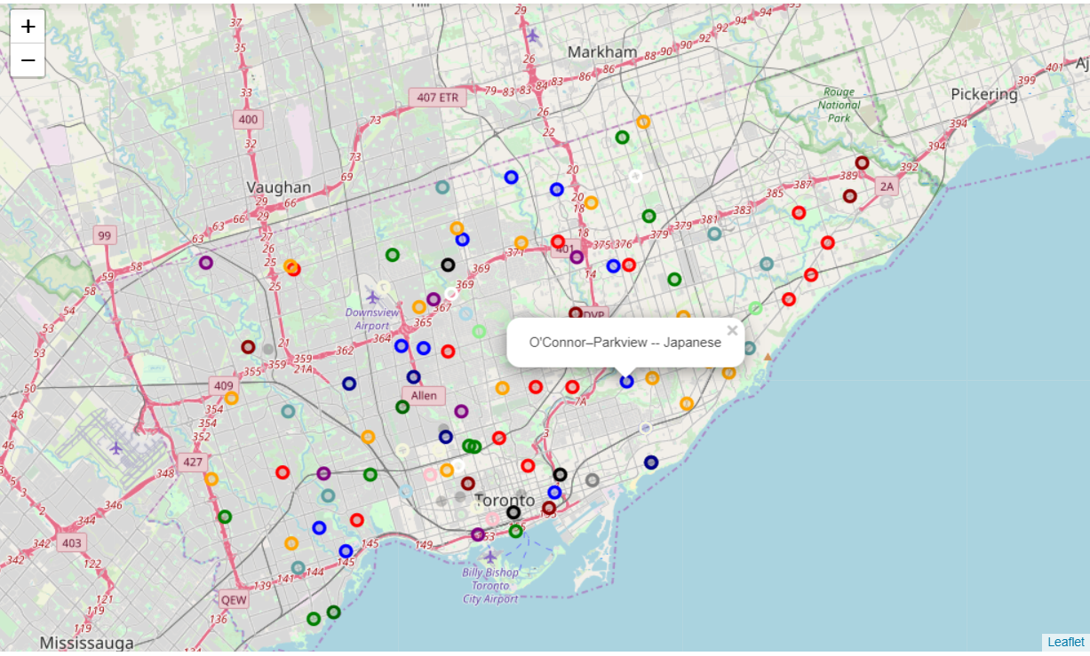

The venue legend for the map is:

| **Venue** | **Color** |
| --- | --- |
| Coffee Shop | Red |
| Café | Blue |
| Pizza Place | Green |
| Japanese | Purple |
| Restaurant | Orange |
| Bakery | Dark Red |
| Chinese | Light Red |
| Fast Food Restaurant | Beige |
| Italian Restaurant | Dark Blue |
| Sandwich Place | Dark Green |
| Mediterranean Restaurant | Cadet Blue |
| Caribbean Restaurant | Dark Purple |
| Indian Restaurant | White |
| Middle Eastern Restaurant | Pink |
| Burger Joint | Light Blue |
| American | Light Green |
| Breakfast Spot | Gray |
| BBQ Joint | Black |
| Dessert Shop | Light Gray |

1. Based on reports of restaurants closing in 2017 and 2018, the following list of number of failed restaurants by Neighborhood was produced.

Table - Count of Restaurant Failures by Neighborhood 2017-2018

| **Neighborhood** | **Restaurant Failures** |
| --- | --- |
| Yorkville | 21 |
| Chinatown | 18 |
| Little Italy | 17 |
| Alexandra Park | 14 |
| The Annex | 8 |
| The Danforth | 7 |
| The Beaches | 7 |
| Cabbagetown | 7 |
| Riverdale | 6 |
| Leslieville | 6 |
| Little Portugal | 5 |
| Roncesvalles | 4 |
| Fort York/Liberty Village | 4 |
| Church and Wellesley | 4 |
| The Junction | 3 |
| Ossington | 3 |
| Leaside | 3 |
| Hillcrest | 3 |
| High Park North | 3 |
| Dundas West | 3 |
| Bloor | 3 |
| Yonge and Eglinton | 2 |
| Yonge and Dundas | 2 |
| St. Clair West | 2 |
| Seaton Village | 2 |
| Parkdale | 2 |
| Old Toronto | 2 |
| New Toronto | 2 |
| Kingsview Village | 2 |
| Financial District | 2 |
| St. Lawrence Market | 1 |
| Seato Village | 1 |
| Rosedale | 1 |
| Riverside | 1 |
| Old Mill/Baby Point | 1 |
| Oakwood Village | 1 |
| North York City Centre | 1 |
| North York | 1 |
| Moss Park | 1 |
| Liberty Village | 1 |
| Koreatown | 1 |
| King West Village | 1 |
| Kensington | 1 |
| Harbor Village | 1 |
| Harbord Village | 1 |
| Gerrard | 1 |
| Garden District | 1 |
| Fashion District | 1 |
| Eglinton West | 1 |
| East York | 1 |
| Dundas and University | 1 |
| Distillery District/West  Don Lands | 1 |
| Cottage | 1 |
| Cliffcrest | 1 |
| Church | 1 |
| Christie Pits | 1 |
| Broadview | 1 |
| Bloordale | 1 |
| Bloor West Village | 1 |
| Allenby | 1 |

1. The first four neighborhoods contain the only double-digit numbers of closings. Each of those areas featured the following venues:

Table - Most Common Venue Closings for Neighborhoods with Double Digit Restaurant Closings

|  |  |
| --- | --- |
| **Neighborhood** | **Most Common Closing Venue** |
| Yorkville | Seafood Restaurant |
| Chinatown | Chinese |
| Little Italy | Italian Restaurant |
| Alexandra Park | Italian Restaurant |

A review of the existing restaurants returned by Foursquare showed that each of these neighborhoods are popular venues for the restaurants closed.

1. Graphically, the number of restaurant failures by neighborhood is:  
   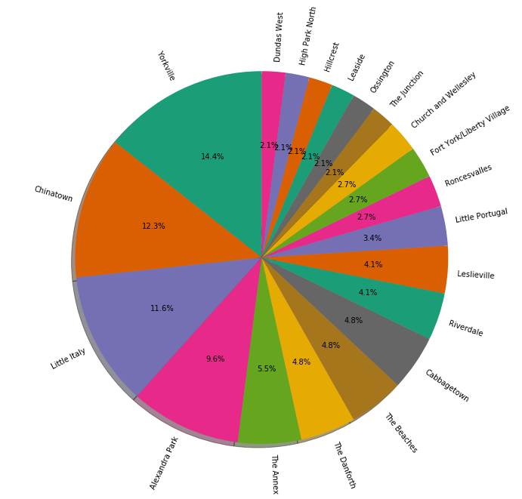

Figure - Restaurant Failures by Neighborhood 2017-2018

1. The observed number of restaurant failures by venue is:

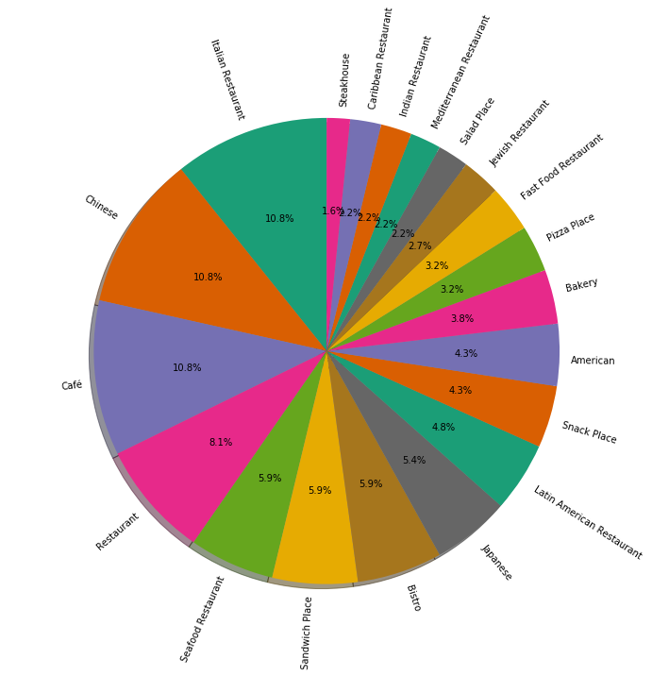

Figure - Restaurant Venue Failures in Toronto 2017-2018

# Results

1. The number, and diversity, of restaurant venues in Toronto is large, offering a number of potential opportunities for new restaurants.
2. There were substantially more quick service venues (e.g., coffee shop, cafe’, pizza shops) that full-service restaurants.
3. Figure 2 shows the most popular restaurant venues, while Figure 5 shows the most frequent failures. This gives the most popular restaurant venue as Coffee Shop, with Japanese being a distant second.
4. Several neighborhoods offered a large potential customer base, for very popular venue:

Table - Some Neighborhood with Potential for Restaurants and Large Customer Base

| **Neighborhood** | **Venue** | **Current #** | **Estimated Customer**  **Base** |
| --- | --- | --- | --- |
| Old East  York | Sandwich Place | 4 | 13,055 |
| Woburn | Generic  Restaurant | 4 | 12,126 |
| L'Amoreaux | Coffee Shop | 4 | 11,465 |

1. Table 4 shows the most popular venue by neighborhood.
2. Only about 5% of restaurants closed in 2017, 3% in 2018. This is well below the expected where most new openings close in the first year, and 70% close in the next 3 to 5 years[2]. This is not an exact comparison, as no information was available about age of existing restaurants.
3. Figure 5 shows the most common venue failures in Toronto in 2017/2018. The most common failure venues should be avoided, especially in high-failure neighborhoods (Figure 4).
4. The following neighborhoods had an unusually large number of failures/closings in 2017/2018:  
   Yorkville, Chinatown, Little Italy, Alexandra Park. Each of those neighborhoods had an established preferred venue (e.g., Yorkville, seafood; Chinatown, Chinese; Little Italy and Alexandra Park, Italian). This confirms the difficulty of successfully opening a specific venue in an area already known for that venue. The exact reason for this was not studied, but could include reduced market share of customers, competition with proven performers, and customer habitation.

# Discussion

Decision factors in starting a new restaurant, with selection of neighborhood and venue is a very complex, and risky, venture. Many of the decision factors are covered in this report. Many additional factors, such as chef, experience in a particular venue, financial backing, and experience in starting other restaurants must also be considered.

Toronto Canada numbers reflect a strong base of customers. The number of successful restaurants which have a unique venue (e.g., Hungarian Restaurants) shows a potential opening for niche restaurants. However, many popular venues are grouped into neighborhoods (e.g., Little Italy, Koreatown, Chinatown), where competition all but prohibits a new, competing, venue.

Incomplete data, and limited information on certain venue types, increases the risk inherit in recommendations. The number of neighborhoods, restaurants, and venues is smaller than those typically used in data science.

# Conclusion

While the results determined in this report are consistent with common sense, these results are based on reduction of a significant amount of real-world observations. This consistent agreement may help the stakeholders accept the results, but should not minimize the need for additional business case analysis, outside this report’s scope.

# Caveat Emptor

The author of this report is not a restaurateur. They have no knowledge about running a business, such as a restaurant. They do not have any business degree.

In an actual data science effort, the data scientist would work closely with the subject matter expert (SME) to determine what areas needed to be explored, and what questions need to be answered.

As such, the author has attempted on-line research (however briefly) in an attempt to come up with reasonable areas of research/questions.

This work, as it stands, should not be used in justifying decisions about starting a restaurant, either in Toronto, or anywhere else.

1. “How to Start a Successful Restaurant”, <https://articles.bplans.com/start-successful-restaurant-guide/>
2. “The Average Life Span of a Restaurant”, <https://yourbusiness.azcentral.com/average-life-span-restaurant-6024.html>